COAL LAB MID-TERM

**Question 1:**

Convert the following code into MIPS Assembly- Send your solution only in Doc File.

**Code:**

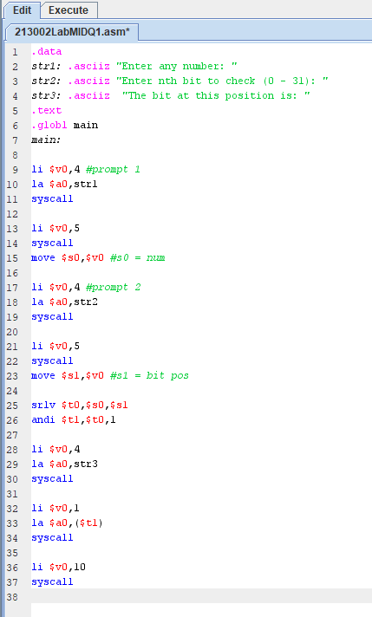

**Output:**

